Blitz Reports Setup Page
Query back Report: XXEN_SCHUB_ITEM_CUSTOM_QUERY
In the SQL statement change the following line:
From | To
, null char01 | xxen_schub_custom_extensions.country_of_origin(msib.inventory_item_id,msib.organization_id) char01

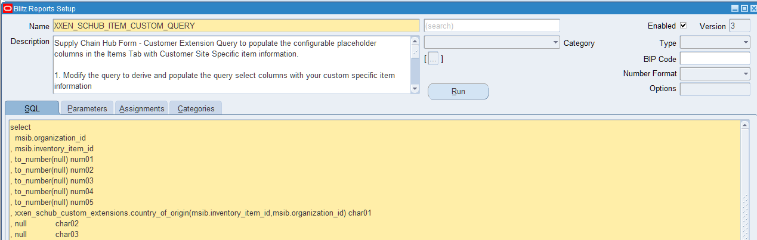

Also comment out the last line (and 1=2) of the SQL Query

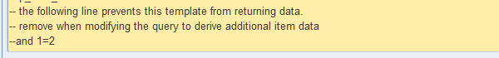
Responsibility: CRM Administrator
Menu: Spreadtable – Metadata Administration
Query back the Datasource Name: XXEN_SCHUB_ITEM_SEARCH_V
Query back Column Alias: CHAR01
In the ‘Display Tab’
- change the Label for ‘Char01’ to ‘COO’ (or whatever title is desired for the Country of Origin)
- check the Visible Property checkbox
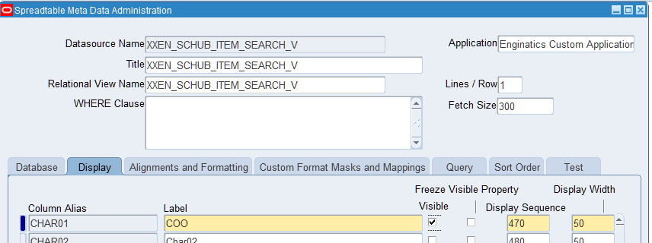

Save the change and dismiss the warming message that pops up when saving the change

Make the same change for the Datasource Name: XXEN_SCHUB_ITEM_SEARCH_V_NOKPI
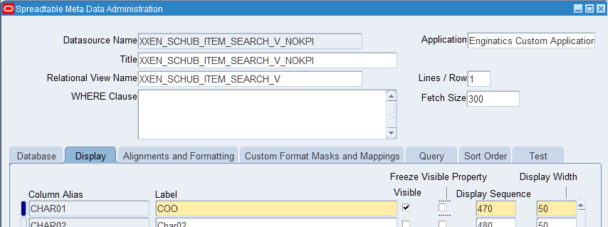

Now the COO column should appear in the Items Tab Grid – it will appear at the end of the Grid:
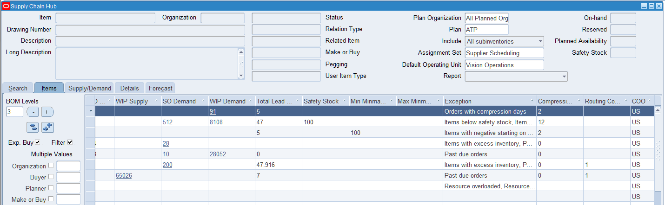

But users can rearrange this as required by dragging the column to where they would like it to appear
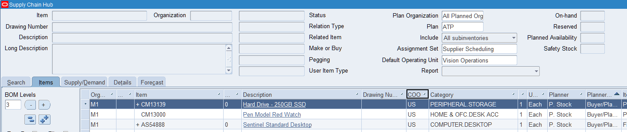

The save the change as a customization, by tight clicking in the grid column headings and select Customizations - Save

